**Module 2 Kinematics of Rigid Bodies**

1. Arm AB rotates anti-clockwise with uniform angular velocity 10 rad/sec. Point C is constrained to move along the X axis. Calculate the angular velocity of bar BC and velocity of point D at the given instant. Also determine the instantaneous velocity of C.

( Ans : ωBC = 3.79 r/s, VD = 2.3 m/s, VC = 2.46 m/s )

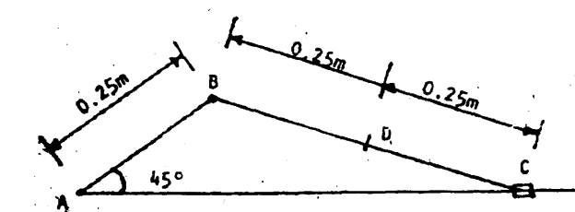

2. A crank AB of a mechanism as shown in Fig above is moving with angular velocity of 2 rev/mm in a clockwise direction. Find the angular velocity of the arm CD when AB makes an angle of 40° with the horizontal.

( Ans : ωBC = 0.16 r/s, ωCD = 0.31 r/s )

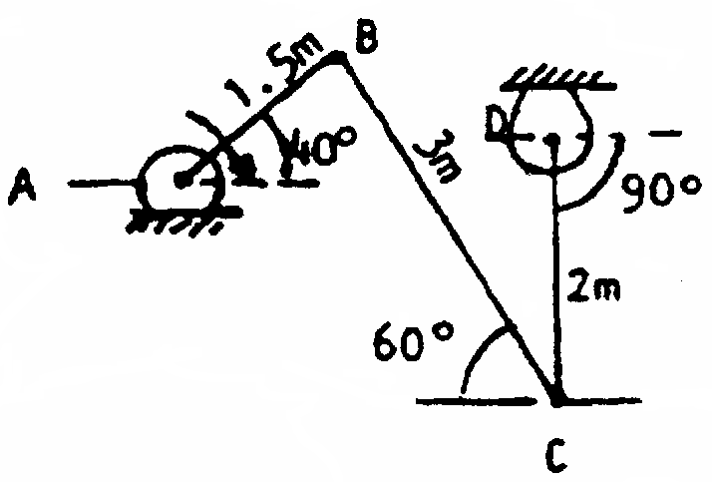

3. A bar AB, 3 m long slides down the plane shown in Fig. The velocity of end A is 3.6 m/s to the right. Determine the angular velocity of AB and velocity of end B and centre C at the instant shown.

( Ans : ωAB = 0.935 r/s, VB =3.74 m/s, VC = 3.38 m/s )

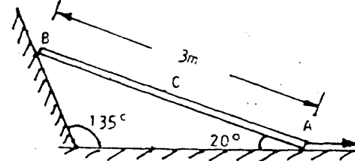

4. AB rotates with constant angular velocity of 15 rad / sec CW. Find angular velocity of CD & velocity of F if F being mid point of BC.

( Ans : ωBC = r/s, ωCD = r/s,

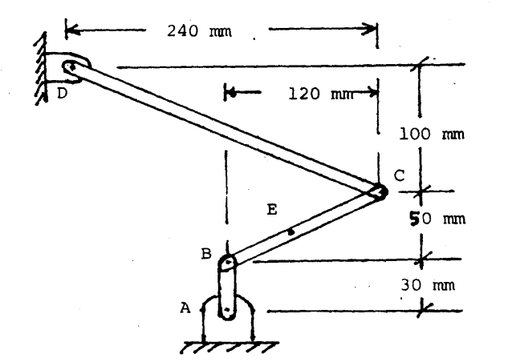

5. A roller of radius 8 cm rides between two horizontal bars moving in the opposite directions as shown in the figure. Locate the instantaneous centre of velocity and give its distance from B. Assume no slip conditions at the points A and B.

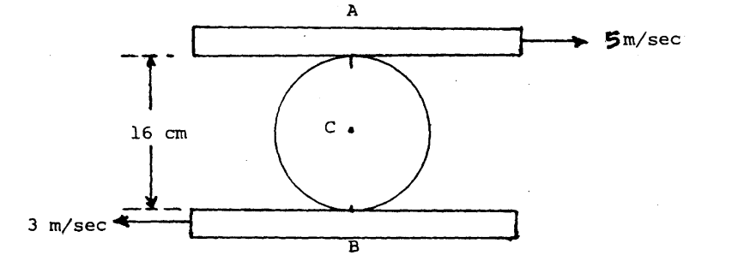

Locate the position of the instantaneous centre when both the bars are moving in the same direction.

( Ans : (i) 6m (ii) 24m )

6. A composite wheel roll without slipping with angular velocity of 60 RPM clockwise as shown in the figure. Determine the absolute velocities of points A, B and E shown in the figure. If it is observed that the wheel slips 50 % find the velocities of points A, B and E.

( Ans : (i) VA = 8.886 m/s, VB = 17.58 m/s, VE = 18.85 m/s (ii ) VA = 7.025 m/s, VB = 8.79 m/s, VE = 5π m/s )

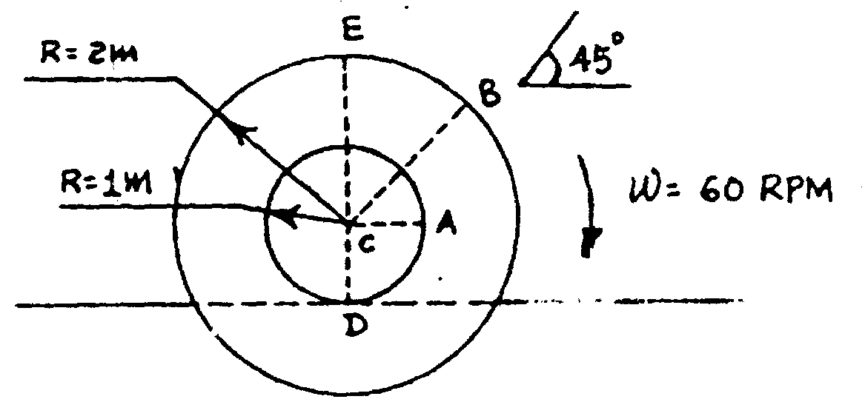

7. (i) A wheel rolls without slipping with angular velocity of 60 RPM clockwise as shown in the figure. For the paints A, B, C, D, E shown in the figure determine the absolute velocities when AO is vertical.

( Ans : VA = 240π mm/s, VB = 200π mm/s, VC = 120π mm/s, VD = 144.22π mm/s, VE = 215.4π mm/s )

(ii) If it is observed that the wheel slips 50 % find the velocities of the same points shown in figure when AD is vertical.

( Ans : VA = 180π mm/s, VB = 140π mm/s, VC = 60π mm/s, VD = 100π mm/s, VE = 161.2π mm/s )



8. Link AB, BC and CD form a mechanism as shown in the figure. If the link CD rotates anti-clockwise around hinge D with an angular speed of 30° per second determine the angular velocity of the link BC and also of link AB.

( Ans : ωBC = 0.191 r/s, ωAB = 0.575 r/s )

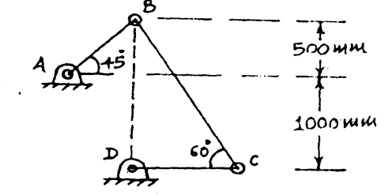

9. Locate the instantaneous centre of rotation of link AB. Find also the angular velocity of link OA. Take velocity of slider at B = 2500 mm/s .The link and slider mechanism is as shown in the figure.

( Ans : ωAB = 5.413 r/s, ωOA = 6.25 r/s )

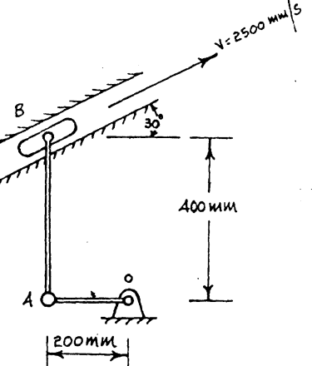

10. Figure below shows a collar B which moves upwards with a constant velocity of 1.5 m/s. At the instant when θ = 50º, determine (1) the angular velocity of rod AB which is pinned at B and freely resting at A against 25° slopping ground and (ii) the velocity of end A of the rod.

( Ans : ωAB  = 1.173 r/s, VA = 1m/s )

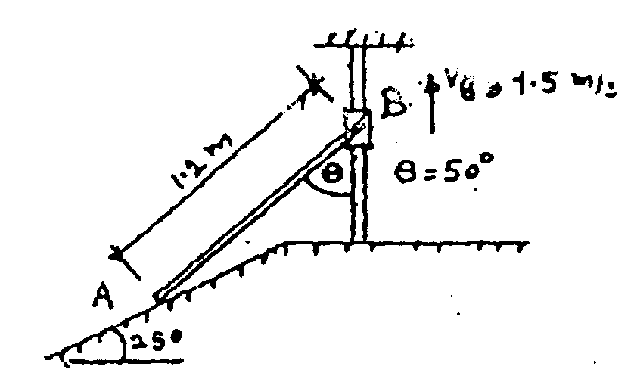

11. A uniform cylinder C to which is pinned a rod AB at A with other end B moving along Vertical wall as shown in Fig. If the end B of the rod is moving upward along the vertical wall at a speed of 3.3 m/s., find the angular velocity of the cylinder assuming the cylinder is rolling without slipping.

( Ans : ωAB = 2.93 r/s, ωCyl = 3.175 r/s )

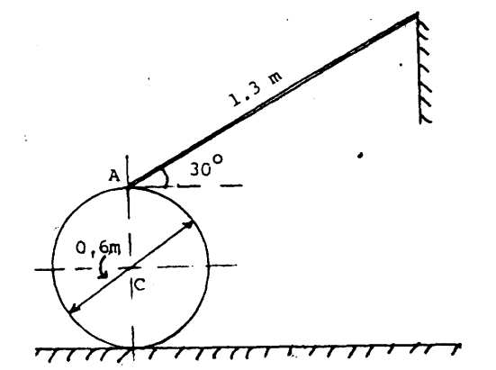

12. Rod BDE is partially guided by a roller at D which moves in a vertical track. Knowing that the instant shown the angular velocity of AB is 5 rad/sec clockwise and β = 25°, determine (i) angular velocity of rod BE (ii) velocity of point E.

( Ans : ωBE = 2.84 r/s, VE = 1817.3 mm/s )

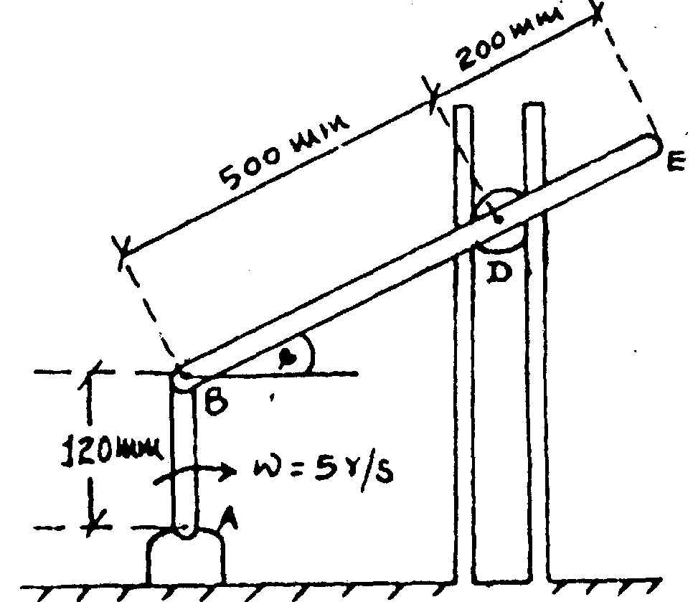

13. If rod AB is rotating with angular velocity ωAB = 12 r/s, determine the angular velocity of rods BC and CD at the instant shown.

( Ans : ωBC = 1.332 r/s, ωCD = 10 r/s )

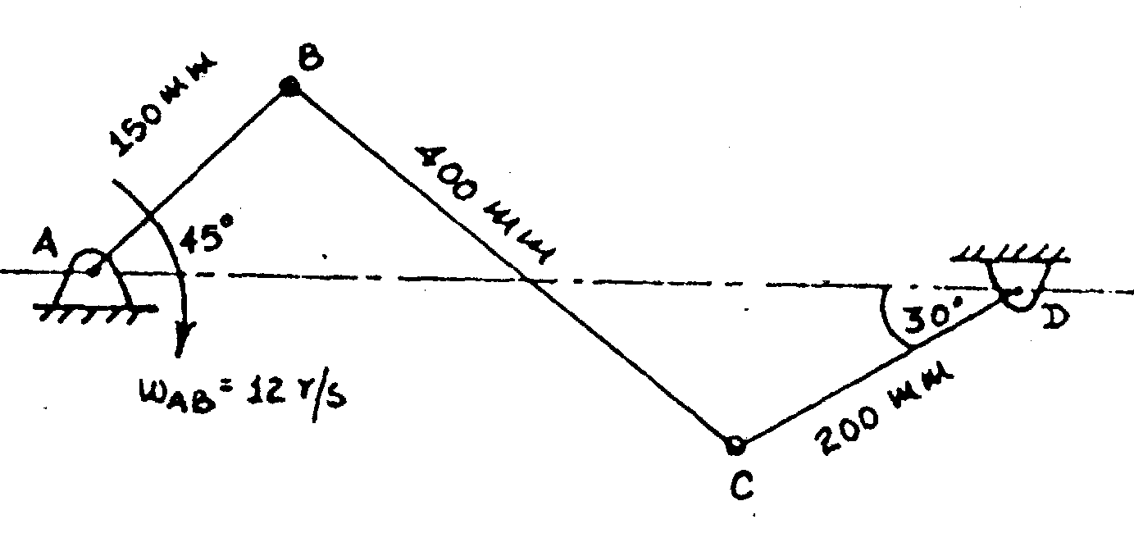

14. End A of the rod AB moves to the left with a constant velocity of 0.9 m/s. For the position shown, determine (i) the angular Velocity of rod AB and (ii) the Velocity of the midpoint C of rod AB.

( Ans : ωAB = 0.6 r/s, ωDB = 1.3 r/s, VC= )

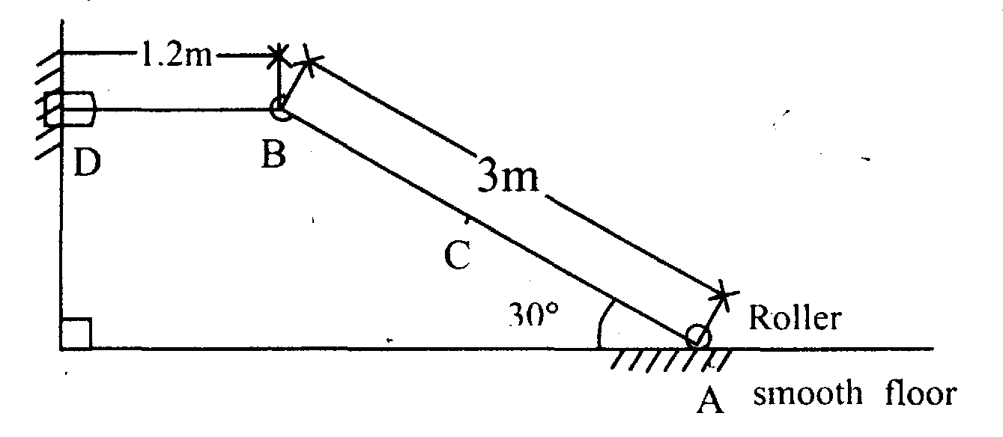

15. In the figure shown, the disc rolls without slipping on the horizontal plane with an angular velocity of 10 RPM clock-wise. The bar AB is attached as shown line OA is horizontal. Point B moves along the horizontal plane. Determine the velocity of point B for the phase.

( Ans : ωAB = 0.524 r/s, VB = 1099.6 mm/s )

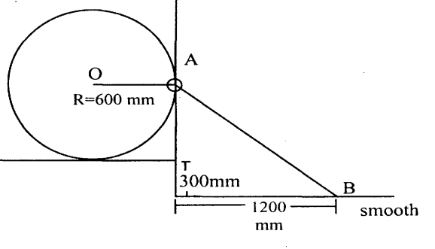

16. A bar AB 24 cm long is hinged to a wall at A. Another bar CD 32 cm long is connected to it by a pin at B such that CB = 12 cm and BD = 20 cm. At the instant shown, (AB ┴ CD) the angular velocities of the bars are ωAB = 4 rad/sec and ωCD = 6 rad/sec. Determine the linear velocities of C and D (Hint : Bar CD is in plane motion).

( Ans : VC = 120 cm/s , VD = 153.67 cm/s )

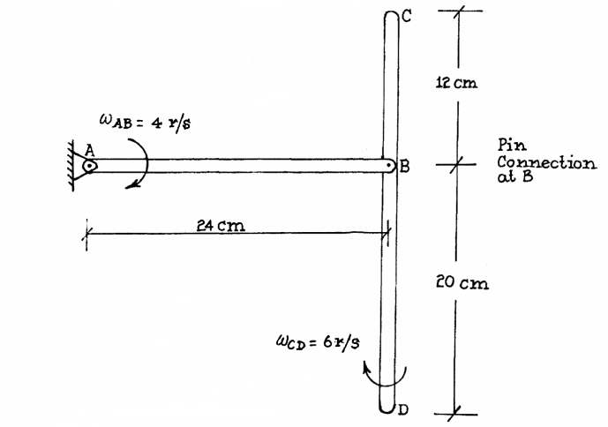

17. Bar BC slides at C in a collar by 4 mIs velocity. The other end B is pinned on a roller. Find angular velocity of Bar BC and the roller.

( Ans : ωBC = 0.38 r/s, ωRoll = 1.88 r/s )

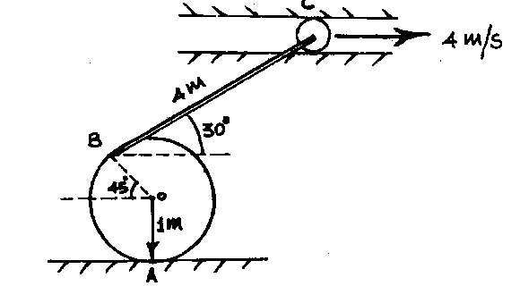

18. The similar link AB and CD rotate about the fixed pins at A and C. If AB has an angular velocity ωAB = 8 rad/s. Determine the angular velocity of BDP and velocity of point P.

( Ans : ωBPD = 4 r/s, ωCD = 8 r/s )

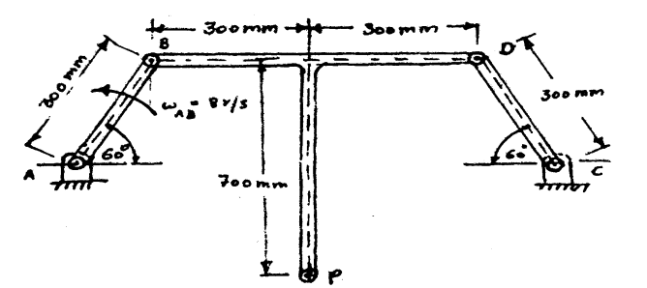

19. At the position shown in figure, the crank AB has angular velocity of 3 rad/s clockwise. Find the velocity of slider C and the point D at the instant shown.

( Ans : VC = 4 , VD = 7.2 )

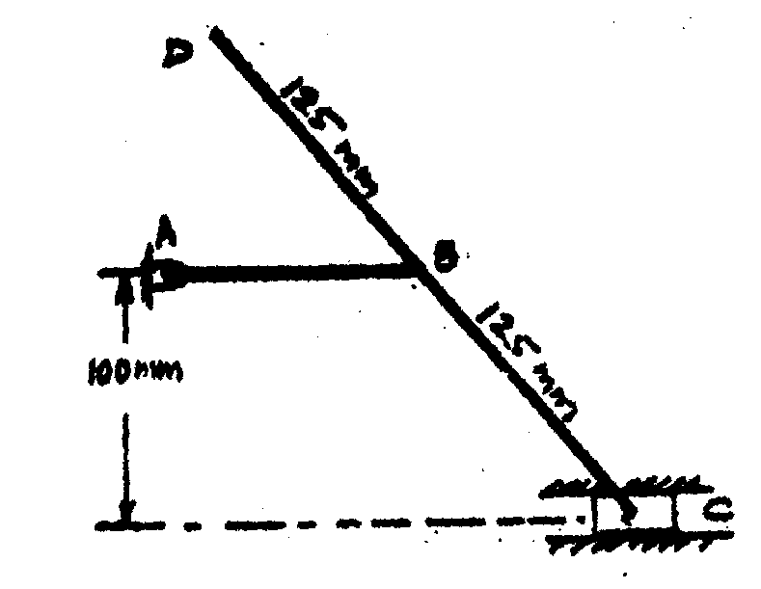

20. (i) Knowing that at the instant shown the angular velocity of rod BE is 4 rad/s counterclockwise, determine (a) the angular velocity of rod AD (b) the Velocity of collar D (c) the velocity of point A.

( Ans : ωAD = 4.2 r/s, AI = 365 mm )

(ii) Knowing that at the instant shown the velocity of collar D is 1.6 rn/s upwards; determine (a) the angular velocity of rod AD, (b) the velocity of point B, (c) the velocity of point A.

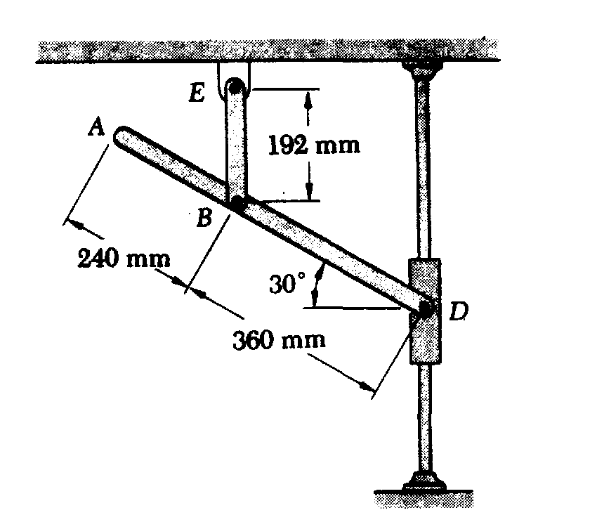

21. A 60-mm-radius wheel is connected to a fixed support D by two links AB and BD. At the instant shown, the velocity of the center A of the wheel is 300 mm/s to the left. Determine (a) the angular velocity of each link, (b) the velocity of pin B.

( Ans : ωAB = 0.384 r/s, ωDB = 0.96 r/s)

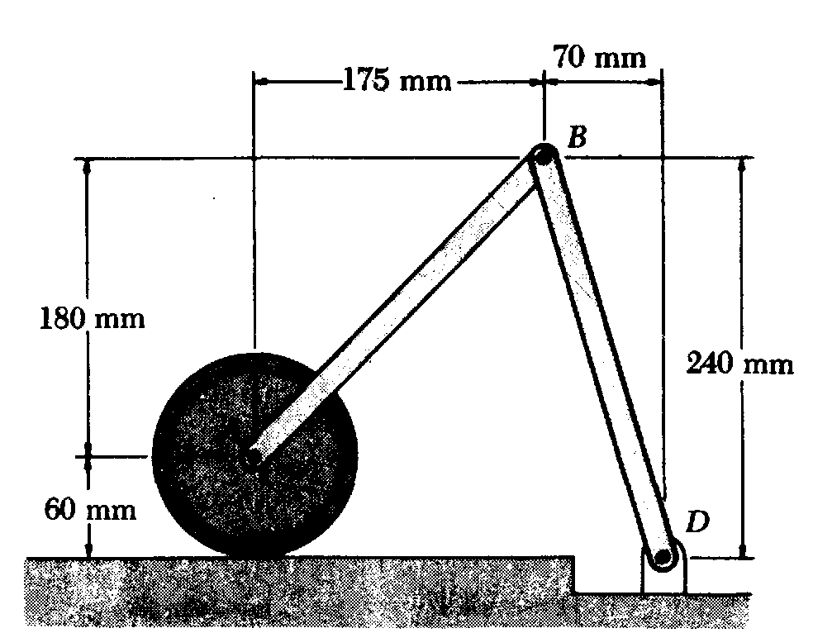

22. Two 500 mm rods are pin-connected at D as shown. Knowing that B moves to the left with a constant velocity of 360 mm/s. determine at the instant shown (a) the angular velocity of each rod, (b) the velocity of E.

( Ans : (a) ωAB = 0.9 r/s, ωDE = 0.337 r/s, VE = 78.63 mm/s )

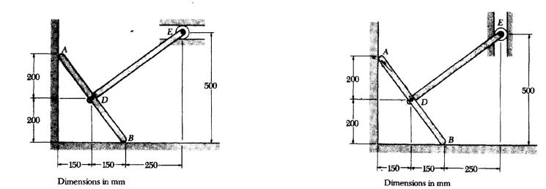

23. The bar ‘BC’ in the given Figure has an angular velocity of 5 rad/s clockwise when it is in the position given below. Determine the angular velocity of the bar AB and also the linear velocity of the point ‘P’ on the bar BC.

( Ans : ωAB = 12.5 r/s, VC = 1500 mm/s , VP = 1209.3 mm/s )

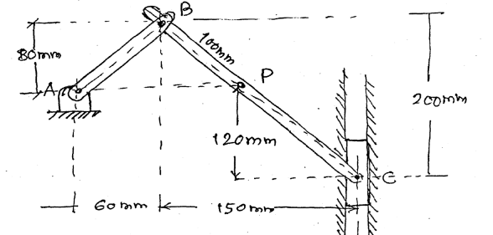

24. Velocity point A on a rod is 2 m/s at the instant shown. Locate I or and determine velocity of pt B on the rod.

( Ans : ωAB = 0.35 r/s, VB = 1m/s )

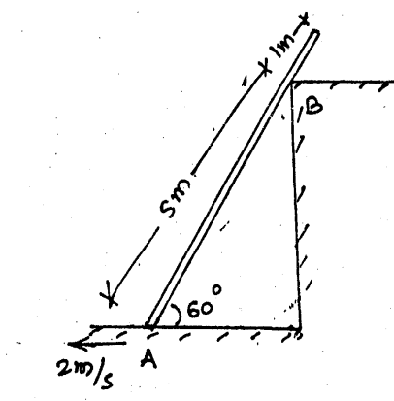

25. If link CD is rotating at 5 rad/sec, anticlockwise determine the angular velocity of link AB at the instant shown.

( Ans : BI = 273mm, CI = 245mm, ωAB = 3.71 r/s, ωBC = 2.05 r/s)

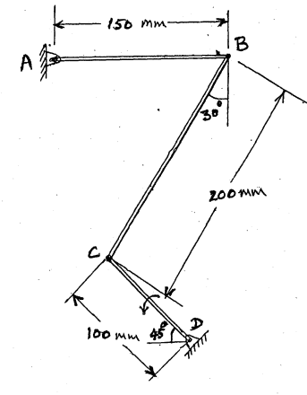

26. A wheel is made to roll without slipping, towards right, by pulling a string wrapped around a coaxial spool as shown in Fig. Determine with what velocity the string should be pulled so that the centre of the wheel moves with a velocity of 10 mIs? [Ans : 6 m/sI

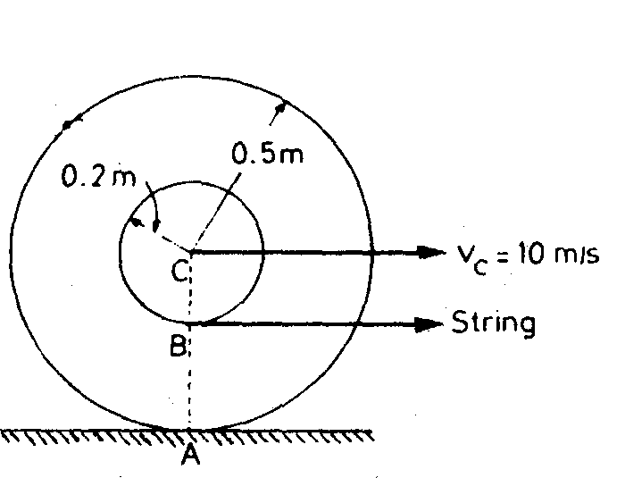

27. A rod AB of length 2 m is in contact with a horizontal surface and an inclined plane as shown in Fig. The end B moves with a constant velocity of 2.4 m/s to the right. Determine the angular velocity of the rod AB and the velocity of the end A when θ = 20°.

( Ans : 1.356 r/s , 2.94 m/s)

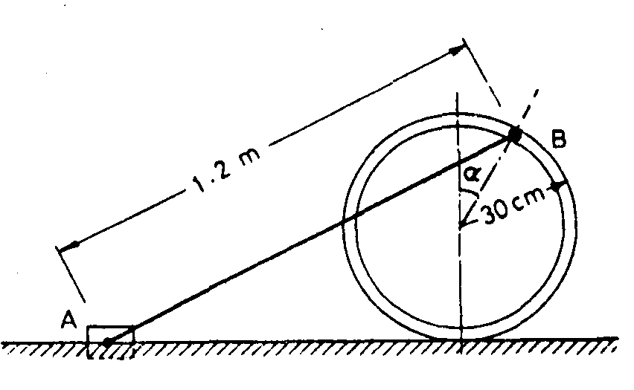

28. The end A of a bar AB moves with a constant velocity = 2 m/s along the horizontal surface such that it always remains in contact with a disc of radius r = 5 cm which is resting on the horizontal surface as shown in Fig. Find the angular velocity of the bar at an instant when the bar makes an angle of α =30° with the horizontal.

( Ans : 11.55 r/s )

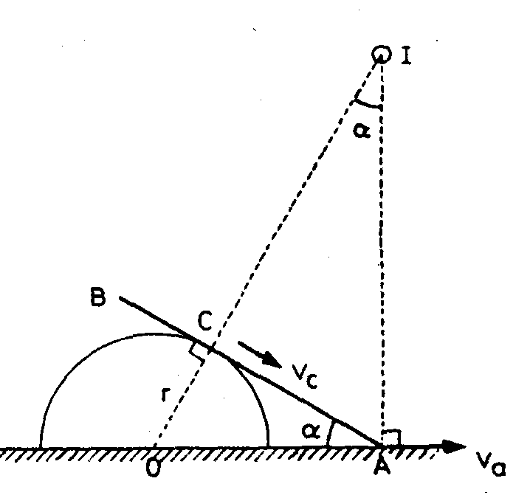

29. A compound wheel rolls without slipping as show in Fig. The velocity of the centre C is 1 mIs. Find the velocities of the points A, B and D.

( Ans : Va = 3 m/s, Vb = 1 m/s , Vd = 2.24 m/s)

